
SYSTEMS DIVISION
Insider Trading System Application Architecture

DRAFT

Prepared By:

Linda Gerdes
Sundar Narayanan
John Parkolap
Rich Gracyzk
Tatiana Kudina
02-Mar-2004

File Name: | 0000.doc
Document  Reference: | Insider Trading System Application Architecture
Version: | Version 1.0
Status: | Draft
Sign-off
Authorized by
Brad Samuels
Contents

1. Introduction 7
1.1 Business Drivers 7
1.2 Technology Drivers 7
1.3 Overview 7
2. Use Case View 8
2.1 User Logon 8
2.2 Display Stock Pick List 9
2.3 Display Stock Detail 11
2.4 Assign Analyst to Daily Sheet 13
2.5 Display Optimal Profit 15
2.6 Display LOPR information 17
2.7 Notify Analyst 19
2.8 Display Aberration Details 20
2.9 Display Open Interest 21
2.10 Display Case List 22
2.11 Display Case Detail 23
2.12 Track Blue Sheet 25
2.13 Display Blue Sheet Information 26
3. Logical View 28
3.1 Logical Packages 31
3.1.1 Client Services 31
3.1.2. Common Services 32
3.1.3. Business Services 33
3.1.4. Infrastructure Services 34
3.1.5. Batch Processes 35
3.1.6. Adapter 38
3.2. Processing Paradigm 38
3.2.1. Foundation Framework 38
3.2.2. Batch 38
3.2.3. JDBC 38
3.2.4. Internet 38
3.2.5. Oracle Packages 38
3.3. User Interfaces 39
4. Process View 40
5. Deployment View 41
5.1 Process Deployment 41
5.2 Processing Needs (Application Layer) 42
5.2.1 Hardware 42
5.2.2 Performance 42
5.2.3 Availability/Reliability 42
5.2.4 Migration 42
5.3 Data Needs (Information Layer) 43
5.3.1 Physical Location 43
5.3.2 Capacity 43
5.3.3 Integrity 43
5.3.4 Access 43
5.3.5 Management 43
5.3.6 Migration 43
5.4 Hardware Installation 44
5.5 Third-Party Products 44
5.6 Software Installations 44
5.7 Maintenance 44
6. Database Model 45

Foreword

The application architecture is a blueprint for what the developers will build. Like a building blueprint, it outlines the major features both physical and functional. It details the type of hardware, if not the specific hardware. It outlines the dimensions of the architecture by specifying the boundaries. It builds-in any required security, capacity, performance, maintenance, and operational needs. It specifies all external and user interfaces to the application. The application architecture is the vision for what the built system should look like. Although the architecture may change slightly over time, it gives the designers and developers a view of what the final product should be.

Scope

The application architecture covers the high level view of the final system. It will provide the vision for other more detailed documents. It will cover both the logical, physical and functional aspects of the application. Although the application architecture is not enough for a developer to begin building the application, it is necessary for providing a common vision and determining synchronization points for multiple teams.

Audience

The system owner should read this document to ensure it captures the owner’s vision for functionality and presentation. The system architect should read this document to ensure it adheres to the enterprise architectural vision and philosophy. The information architect should read this document to ensure it properly captures the business functionality. The infrastructure architect should read the document to ensure that the application uses the infrastructure items wherever possible. The technology architect should read this document to ensure the application properly uses the appropriate technologies. The system engineer should read this document to understand the vision and constraints placed on the system. The system engineer will reference this document when building the system requirements and performing system analysis. The designer should read this document to ensure his design captures the architect’s intent. The developer should read this document to ensure the implementation realizes the architect’s vision of the application.

Prerequisites

Readers should be familiar with the system architecture, the information architecture, the infrastructure architecture, and the technology architecture for this project.

Organization

- The Introduction section contains background information, the business driver force and the technical driver force for the system, and an overview of the system context.
- The Use Case View section provides the motive and describes the system needs in concrete terms.
- The Logical View section describes the static and dynamic aspect of the system in terms of packages, subsystems, components, and their responsibilities.
- The Process View section represents the decomposition of components in terms of execution flows. Process View also represents the synchronization between the components and the availability and reliability of them at the process level.
- The Deployment View section describes how the processes are deployed at the processor level. It discusses the scalability and fault tolerance features of the system. The hardware and software tools are also documented here.

Introduction

This document addresses the application architecture of Insider Trading System that Regulatory systems group will deploy to support and enhance the work of Regulatory Insider Trading group.

Business Drivers

Insider Trading System is developed to enhance the process of regulatory Insider trading group in identifying potential insider trading trades. The system consolidates the reports required in the process under one system and will aid the users in their work.

Technology Drivers

With the growing popularity of the Internet and n-tier applications, the support for client-Server applications is dwindling. The CBOE management also wants to standardize development and use a common technology to develop applications across the board. The Insider trading system will primarily be developed as an Internet based application using the CBOE Direct development model. The system will be developed using Struts as the front-end tool to render web pages communicating with Business Services developed using Foundation Framework.

Overview

Currently the Insider Trading group conducts the Insider trading surveillance with the use of multiple tools. They use MSS Online reports, IAD reports, MS Access databases and the web to conduct Insider trading surveillance. The Aberration Report produced by IAD involves a manual step of invoking a SAS job to create the report. The report is usually available after 10:00 am. During investigation an ICT number must be assigned which is another manual step. Due to the multiple sources involved in the surveillance, there is a certain amount of manual work involved in comparing and cross-referencing data.

Combining the reports in one application will reduce the manual operations performed by the staff and provide a more efficient method for investigators to retrieve data needed for analysis.

Use Case View

User Logon

Use Case Name | User Logon
Actor | Insider Trading Manager, Insider trading Analyst
Pre-conditions /Assumptions | User has Internet explorer and is aware of the http path to the application
Post conditions | If the user is a Manager then the user will be automatically directed to the “Stock Selection”. If the user is an Analyst then the user will be directed to the “Case Selection“ screen
Flow of Events | - The user will submit the User-ID and password  - A login request is sent to the system with user ID and password and is validated with the server  - System will send a success message on successful message
Alternative Paths | If the user submits an invalid user id or password in the system, the system will validate and send an “invalid login” message to the user  If the system is down and the validation could not be performed then the system will send a “System down, contact systems support” message to the user
Frequency | - 8 managers or analysts  - Login 2 times during day
Notes: | If the user does not remember the user id/Password they should contact the administrator (ICT) to retrieve their information
Performance Requirements

Data Access Scenarios | Tables and Access Path | Percent Rows Retrieved | Average Frequency
User Password Retrieval | Retrieve STAFF_PERS using staff_pers_user_name | 1 row | 16 retrievals per day
User Roles Retrieval | Union of tables:  - DEPT_AREA_ASGNMT using staff_pers_user_name and Role Department Area conversion table  - Non regulatory staff person role table using user name | 1 row, 5%  1 row 1%  5 rows, 50 % | 16 retrievals per day

Display Stock Pick List

Use Case Name | Display Stock Pick List
Actor | Insider Trading Manager
Pre-conditions /Assumptions | A success message from Login
Post conditions
Flow of Events | - Display stocks using default criteria of previous trade date and where  (ABS(Net Change) >= 1.00 (Default dollar Amount Criteria) and  News Indicator = 'Y' and  % Price Movement >= 8% (Default % movement Criteria) )  OR  (ABS(Net Change) >= 1.00 (Default dollar Amount Criteria) and  % Price Movement >= 8% (Default % movement Criteria) and  Percent difference between the trade date net price change and the average net price change >= 200%)  - The default criteria can be changed to display stocks that meet the criteria  - Trade date, percentage or dollar amount  - The business Indicators will be displayed for the date chosen and comments can be entered for the review date  - DJ Ind close  - DJ Ind change  - NASDAQ composite close  - NASDAQ composite change  - CBOE Contracts  - General Comments (User Input)  - The following information for the stock will be displayed  - Trade date  - Underlying Instrument symbol  - News Indicator (Y/N) for the trade day to indicate that there is news available  - Composite close selected across all exchanges  - Net change in price at the principal exchange  - Average net change over an average number of days (usually 30 days)  - Percent difference between the trade date net price change and the average net price change.  - Price Movement Percentage  - Aberration indicator to indicate if the stock had an aberration. The indicator will indicate if the aberration is on Volume (V) or Open Interest (OI) or both (VOI). There will be a hyperlink created on the indicator which would direct the user to Aberration detail report for the stock  - Daily sheet Indicator (Y/N) If set to ‘Y’ then indicates that the stock has already been added to the daily sheet for the provided trade date  - ICT #  - A particular stock can be chosen to review in detail. (Directed to “Display Stock Detail” )
Alternative Paths | If no stocks meet the criteria, a blank window is displayed and user can change input criteria
Frequency | - 1 manager performs function  - 30 stocks on average pick list
Notes:

Performance Requirements
Data Access Scenarios | Tables and Access Path | Percent Rows Retrieved | Average Frequency
Business Indicators Retrieval | Via existing BUS_IND view using trade_date as selection criteria to retrieve DJIA, NASDAQ close, change and CBOE volume. | 1 row | 30 retrievals per day
General Business Climate Retrieval | Select ITS_MRKT_COMNT by trade_date | 1 row | 30 retrievals per day
General Business Climate Update | Update ITS_MRKT_COMNT by trade_date | 1 row | 1 update per day
Stock Information Retrieval | Selection criteria on existing UNDLY_INST_SUM table using trade_date (PK), undly_inst_sym (PK) , news_ind, net_chg, and cpst_close columns. Table supplies end-of-day data on stock.  To supply aberration data, outer join to UNDLY_SEC_ABERR since there may not be aberration data for the underlying symbol and trade date  To supply daily sheet data, outer join to ITS_DAILY_SHEET table using trade_date and underlying symbol | 2% of rows for trade date.  30 rows  Estimate 10% of rows for trade date or 30 rows  Estimate 100% of rows for trade date or 25 rows | 30 retrievals per day

Display Stock Detail

Use Case Name |  | Display Stock Detail
Actor |  | Insider Trading Manager / Analyst
Pre-conditions /Assumptions |  | User logged on to the system  Manager chooses a particular stock from the “Stock Pick List” window  Analyst chooses a particular stock from case Detail window
Post conditions
Flow of Events |  | - Display the stock information for the stock chosen for news date to 10 days prior  - Underlying Symbol  - Trade date  - News indicator (Y/N)  - Composite Volume  - Primary Exchange close  - High  - Low  - Net change  - Option clear volume  - Option open interest  - Aberration indicator to indicate if the stock had an aberration. The indicator will indicate if the aberration is on Volume (V) or Open Interest (OI) or both (VOI). There will be a hyperlink created on the indicator which would direct the user to Aberration detail report for the stock  - DJIA net change  - NASDAQ net change  - Daily Sheet Status – The status as of now  - Analyst assigned for the Daily sheet – will be null if there was no daily sheet entry or nobody was assigned to the pick  - The default criteria, Trade date range and the Stock symbol input, can be changed to display the corresponding information  - Manager has ability to invoke the following information for the stock to decide whether the stock requires further review by analyst  - Aberration Details  - LOPR  - Optimal Profit  - Open Interest  Analyst will not see this information  - If the Manager decides that the stock does not require any further review the user can “close” with optional comments. Analyst will not see this information  - If the Manager decides that the stock requires further review the stock can be added to daily sheet with optional comments/ news headlines/ instructions. Analyst does not see this information  - The Manager has the ability to reopen and add a stock to daily sheet that has been closed. Analyst does not see this.
Alternative Paths
Notes
Frequency |  | - 1 manager performs function, displays detail on 30 stocks on average  - 7 analysts performs function each displays detail on 5 stocks as an average
Performance Requirements
Data Access Scenarios | Tables and Access Path |  | Percent Rows Retrieved | Average Frequency
Stock Information Retrieval | Selection criteria on existing UNDLY_INST_SUM table using single undly_inst_sym and trade date range. Table supplies end-of-day data on stock.  To supply option volume and open interest, select off new class summary table joined with class_arch by class symbol and trade date range, summing clear volume and open interest by trade date.  Aberration data supplied by outer join to UNDLY_SEC_ABERR since there may not be aberration data for the underlying symbol and trade date range  Daily sheet data supplied by outer join to ITS_DAILY_SHEET table using trade_date and underlying symbol  BUS_IND view using trade date range to retrieve market summary data |  | 0.1% of rows for trade date range.  11 rows  33 rows  Estimate <1% of rows for trade date range or 2 rows  Estimate <1% of rows for trade date range or 1 rows  100% of trade date range rows or 11 rows | 65 - 100 retrievals per day
Daily Sheet Insert | Insert ITS_DAILY_SHEET row using underlying symbol and trade date. |  | 1 row | 30 inserts per day
Daily Sheet Status Update | Update ITS_DAILY_SHEETwith status and comment for a underlying symbol and trade date |  | 1 row | 5 updates per day (assumption)

Assign Analyst to Daily Sheet

Use Case Name |  | Assign Analyst to Daily Sheet
Actor |  | Insider Trading Manager
Pre-conditions /Assumptions |  | User logged on to the system  User chooses the Daily Sheet Assignment from the menu
Post conditions
Flow of Events |  | - Display all the daily sheet entries for the prior trade date  - The business indicator information will be displayed  - Dow close,  - Dow net change  - NASDAQ close  - NASDAQ net change  - General comment (that was entered in Stock Selection)  - The following daily sheet information will be displayed for each entry  - News Date  - Underlying symbol  - Exchanges that the symbol trades in  - Price Change  - Analyst (The users will be provided with a list of analysts to choose from. By Default, a new entry will have an unassigned)  - ICT Number  - Status of the assignment  - Unassigned  - Assigned  - “Error”  - Fast Close out (FCO)  - Investigation  - Auto Close  - Watch (Keep an Eye on)  - Status Date  - Investigation Completion Date  - Comments  - Referral Information  - ICT Status  - An Analyst can be assigned to each entry  - The status of an existing assignment can be changed to  - FCO  - INV  - Error  - Assigned  - When an analyst is assigned, the status will change automatically to “Assigned”  - An ICT case will be created when an analyst is assigned  - Analyst will be notified by email upon assignment  - Manager can reassign a case. If ICT# is already created, no new numbers will be created. New analyst will be notified by email  - Dates can be changed to view the assignments for a given date
Alternative Paths
Notes |  | The system will not handle the case of mergers where both stocks are listed in the daily sheet. There will still be two different ICT #s assigned to this case. ICT will link them both.
Frequency |  | - 1 manager performs function, displays detail on 30 stocks on average
Performance Requirements
Data Access Scenarios | Tables and Access Path |  | Percent Rows Retrieved | Average Frequency
Business Indicators Retrieval | Via existing BUS_IND view using trade_date as selection criteria to retrieve DJIA, NASDAQ close, change and CBOE volume. |  | 1 row | 1 retrieval per day
General Business Climate Retrieval | Select ITS_MRKT_COMNT by trade_date |  | 1 row | 1 retrieval per day
Daily Sheet Information Retrieval | Daily sheet data supplied by retrieve of ITS_DAILY_SHEET table using trade_date  Outer join with STAFF_PERS to retrieve analyst name using STAFF_PERS_USER_NAME  Outer join with REG_LOG by REG_LOG_UID |  | 33 rows  1 row  1 row | 65 - 100 retrievals per day
Analyst Retrieval | Join of two tables  Select DEPT_AREA_ASGNMNT using dept_uid, dept_area_code to retrieve analyst’s staff_pers_user_name  Use staff_pers_user_name to select last_name, first_name from STAFF_PERS |  | 8 rows, 1%  8 rows, 1% | 65-100 retrievals per day
Assign Analyst Update | Insert ICT log row.  Update ITS_DAILY_SHEET using underlying symbol and trade date.  Retrieve STAFF_PERS email address using staff_pers_user_name |  | 1 row  1 row  1 row | 30 inserts per day
Daily Sheet Status Update | Update ITS_DAILY_SHEETwith status and comment for a underlying symbol and trade date |  | 1 row | 5 updates per day (assumption)
Daily Sheet Status Description Retrieve | Retrieve ITS_DAILY_SHEET_STATUS_CODE to retrieve descriptions of the various daily sheet statuses. |  | 7 rows

Display Optimal Profit

Use Case Name |  | Display Optimal Profit
Actor |  | Insider Trading Manager and Analyst
Pre-conditions /Assumptions |  | User logged on to the system  User chooses the Optimal Profit report from the stock Detail  User chooses the Optimal Profit report from the menu
Post conditions
Flow of Events |  | - Optimal Profit report will be displayed for a stock chosen using the following default criteria  - News date to 10 days prior to News date for the selected stock (From Stock Detail)  - News date will remain the profit date  - The Contract quantity  - Buy Call / Sell Put or Sell call / Buy Put – If the news is beneficial and the net price change increases, the buy call/sell put is the default. Otherwise the net price change decreases so the sell call/buy put would be the default  - Open will be the default  - Underlying Security Symbol will be the stock (From Stock Detail)  The default criteria can be changed and following information retrieved  - Clearing firm (005 C)  - Trade Date  - Buy/ Sell  - Open / Close  - Series  - Quantity  - Series percent  - Premium Price  - Profit  - Exchange code  - Cost / Revenue  - Optimal  - Time  - Optional Firm data  - Summary Information  - A particular firm and series can be chosen to review the LOPR information
  Price Change | Open Volume
  0 to 2.5 points | 100 Contracts or more
  2.5625 to 5 points | 50 Contracts or more
  5.125 to 10 points | 25 Contracts or more
  10.125 or more | 10 Contracts or more?
Alternative Paths
Notes:
Frequency |  | - 1 manager performs function  - 7 analysts perform function
Performance Requirements

Data Access Scenarios | Tables and Access Path |  | Percent Rows Retrieved | Average Frequency
Optimal Profit Retrieval | Retrieve series summary information from joined tables SERIES_SUM,  and CLASS_ARCH joined by class symbol using underlying instrument symbol and trade date range as selection criteria.  For each series, retrieve sum of contract quantity by exchange code, trade date, trade time, clearing firm, origin code … from the TRADE_HIST_MAST and  and TRADE_HIST_DTL and  BEST_TRADE_TIME_MAST join  Retrieve non-CBOE trades for each series from the TRADE_HIST_NON_CBOE table |  | 700 rows,  0.1%  30 rows, <0.1% of rows  100 rows, <0.1%  200 rows <0.1%  100 rows,  <0.1%  2460 rows,  <0.1% | assume 30-60 retrievals per day

Display LOPR information

Use Case Name |  | Display LOPR information
Actor |  | Insider Trading Manager and Analyst
Pre-conditions /Assumptions |  | User logged on to the system  User chooses to review LOPR information from Optimal Profit report  User chooses to review LOPR
Post conditions
Flow of Events |  | - The Optimal Profit information can be used as an input for displaying LOPR information  - Clearing firm (005 C)  - Trade Date  - Series  - Buy/.Sell  - Open / Close  - Quantity  - Series Total (sum of the quantity for the series by clearing firm)  The Corresponding LOPR information will be displayed for the trade date, firm and series. This feature will be available only when the users choose the LOPR report from Optimal Profit report.  - LOPR information can also be reviewed on the following input criteria  - Trade date range  - Underlying instrument  - Firm  - Account Number  - SSN / Tax ID  - The following information will be displayed  - Firm  - Branch  - Account  - Customer ID  - Customer ID indicator (SSN or Tax ID)  - Customer name and address  - Position effective date  - Series  - Long quantity  - Short covered quantity - During investigation, analysts can eliminate people from insider trading if they are hedged. In short call/long put situations using options to hedge stocks is acceptable so it is good to have the short covered quantity displayed in LOPR.  - Short uncovered quantity  - Filter capabilities will be provided on the following  - Firm  - Series  - SSN  - Customer Address  - Account Number  - Zip Code  - User can choose to Track Blue Sheet for the firm. The information will be stored to assist the users in keeping track of Blue Sheets using Blue Sheet Tracking Report. This feature will be available only when the users choose the LOPR report from Optimal Profit report. Available to Analyst only
Alternative Paths
Notes:
Frequency |  | - 1 manager performs function  - 7 analysts perform function
Performance Requirements
Data Access Scenarios | Tables and Access Path |  | Percent Rows Retrieved | Average Frequency
Optimal Profit Retrieval | Retrieve series information from the TRADE_HIST_MAST and TRADE_HIST_DTL, BEST_TRADE_TIME_MAST join using series, trade date, clearing firm, buy/sell code, open/close as selection criteria. Union with TRADE_HIST_NON_CBOE for  non-CBOE trades. |  | Est 100 rows per trade date  < 0.1 % of trade date rows | Assume 30-60 retrievals per day
LOPR Retrieval | Retrieve LOPR_POS_DTL for specific class symbol and date range. Read in reverse position effective date order. Use only the first position read for a given series and customer.  Join with LOPR_POS for customer identification using lopr_pos_uid.  Outer join with LOPR_POS_HEDGE_DTL using lopr_pos_uid and underlying symbol to retrieve hedge data. |  | 100 rows  < 0.1%  50 rows  < 0.1%  20 rows  < 0.1% | Assume 30-60 retrievals per day
Blue Sheet Tracking Insert | Insert Blue Sheet Tracking row using ICT number, and OCC Firm number |  | 1 row inserted | 35 - 70 per day

Notify Analyst

Use Case Name |  | Notify Analyst
Actor |  | Batch
Pre-conditions /Assumptions |  | Blue sheet information is loaded for the day by data warehouse
Post conditions
Flow of Events |  | - The batch process will compile the list of all blue sheets that was received for the trade date  - For each Blue sheet received the following steps from 3 to 4 is done  - Process will look up the analyst who requested it using the daily sheet information. If no entry was found go to step 2 for the next blue sheet  - The process will notify the analyst through email indicating the arrival of blue sheet from the firm they requested
Alternative Paths
Notes:
Frequency |  | - Batch Process  - 8 times per day
Performance Requirements
Data Access Scenarios | Tables and Access Path |  | Percent Rows Retrieved | Average Frequency
Notify Analyst | Retrieve distinct ICT numbers from blue sheet data (BLUE_SHEET) by current processing date  Insert new its_bs_track_rcd for each ICT number and firm selected from Blue_sheet.  Retrieve ITS_DAILY_SHEET by ICT number to retrieve analyst name,  Retrieve STAFF_PERSN row by analyst name to get email address. |  | 5 rows avg  < 0.1%  1 row  1 row  1 row | 8 per day

Display Aberration Details

Use Case Name |  | Display Aberration Details
Actor |  | Insider Trading Manager & Analyst
Pre-conditions /Assumptions |  | User logged on to the system  Manager clicks on the Aberration indicator in the stock Detail  Manager clicks on the Aberration indicator in the stock pick List  Analyst clicks on the Aberration indicator in the case detail  Manager/Analysts chooses the Aberration report from the menu
Post conditions
Flow of Events |  | - Aberration detail can be displayed for a stock using the default criteria  - The underlying symbol  - News date to News Date - 10  The default parameters can be changed to display the report  - The report will list the following aberration information  - Underlying instrument symbol  - Trade date  - Cleared volume of all options for the underlying  - Open interest on all options for the underlying  - Aberration type (volume, open interest, Volume and open interest)  - Number of days in the average (30 or 60)
Alternative Paths
Notes:
Frequency |  | - 1 manager performs function  - 7 analysts perform function  - Assume half of stocks on pick list have aberrated options
Performance Requirements
Data Access Scenarios | Tables and Access Path |  | Percent Rows Retrieved | Average Frequency
Aberration Retrieval | Using underlying symbol and news date range, retrieve aberration table rows |  | 0.25% or 10 rows for trade date range | Assume 15-30 retrievals per day

Display Open Interest

Use Case Name |  | Display Open Interest
Actor |  | Insider Trading Manager & Analyst
Pre-conditions /Assumptions |  | User logged on to the system  Manager clicks on the Open Interest report from Stock Detail Report  Analyst clicks on the Open Interest Report in the case detail  Manager/Analysts chooses the Open Interest report from the menu
Post conditions
Flow of Events |  | - The Open Interest information will be displayed for a stock chosen from the stock / Case detail screen using the following default parameters as the input  - Trade date start will be date prior to News date  - Trade date end will be date after News date  - Symbol will be the symbol under review  - In case the report is launched from Menu, the user submits the Underlying symbol and the trade date range to retrieve the information  - The report displays option open interest on the long side (long call and short put) and short side (short call and long put) by clearing firm for the input trade date range
Alternative Paths
Notes:
Frequency |  | - 1 manager performs function  - 7 analysts perform function
Performance Requirements
Data Access Scenarios | Tables and Access Path |  | Percent Rows Retrieved | Average Frequency
Open Interest Retrieval | Join of two tables:  Retrieve class symbols from CLASS_ARCH using the underlying instrument symbols and trade date range  Retrieve ACCT_OPEN_INT rows based on trade date range and class symbols (and origin code when used from case detail) |  | 9 rows  < 0.01% for date range  4564  <0.1% | assume 30-60 retrievals per day

Display Case List

Use Case Name |  | Display Case List
Actor |  | Analyst
Pre-conditions /Assumptions |  | User logged on to the system
Post conditions
Flow of Events |  | - Display list all the cases assigned to the analyst that have not been closed in ICT upon successful login of the analyst  - The analyst can choose a particular case to review the case detail  - Following information will be displayed for each case  - News Date  - Stock Symbol  - Price Change  - Date of Assignment  - % Price Movement  - Daily Sheet Status  - Daily Sheet Status date  - ICT #  - ICT Status
Alternative Paths
Notes:
Frequency |  | - 7 analysts perform function  - 10 to 30 times a day each
Performance Requirements
Data Access Scenarios | Tables and Access Path |  | Percent Rows Retrieved | Average Frequency
Case List Retrieval | Join of several tables:  Retrieve ITS_DAILY_SHEET using staff person user name (assuming available in application)  Retrieve ITS_DAILY_SHEET_STAT_CODE based on ITS_DAILY_SHEET.ENTRY_STAT_IND  Retrieve ICT status from REG_LOG using ITS_DAILY_SHEET.REG_LOD_UID (outer join) |  | Estimated 30-50 rows  1 row per daily sheet  1 row per daily sheet | Assume 30-60 retrievals per day

Display Case Detail

Use Case Name |  | Display Case Detail
Actor |  | Analyst
Pre-conditions /Assumptions |  | User logged on to the system  User choose a particular case in Case List to review the detail
Post conditions
Flow of Events |  | - For a case chosen from the case list, The Business Indicator information will be displayed for the news date  - News date  - DJ close  - DJ change  - NASDAQ composite close  - NASDAQ composite change  - CBOE Contracts  - General Comment  - The Case detail information will be displayed from the daily sheet for the selected case  - Stock Symbol  - Price Change  - Date of Assignment  - % Price Movement  - Daily Sheet Status  - Daily Sheet Status date  - ICT #  - ICT Status  - Daily sheet comment  - The stock information for the selected symbol and news date will be displayed  - Composite volume  - Composite Close  - High price  - Low price  - Opening Price (usually get from ILX)  - Opening share size (usually get from ILX)  - Time of Open  - News Indicator  - Cleared volume  - Aberration Indicator to indicate if the stock had an aberration. The indicator will indicate if the aberration is on Volume (V) or Open Interest (OI) or both (VOI). There will be a hyperlink created on the indicator which would direct the user to Aberration detail report for the stock  - DJI net change  - NASDAQ net Change  - The users can review the following information for the stock and news date  - Stock Detail  - LOPR  - Optimal Profit  - Blue Sheet Tracking  - Open Interest
Alternative Paths
Notes:
Frequency |  | - 7 analysts performs function  - Each displays detail on 20 stocks as an average
Performance Requirements
Data Access Scenarios | Tables and Access Path |  | Percent Rows Retrieved | Average Frequency
Business Indicators Retrieval | Via existing BUS_IND view using trade_date as selection criteria to retrieve DJIA, NASDAQ close, change and CBOE volume. |  | 1 row | 160 retrievals per day
General Business Climate Retrieval | Select ITS_MRKT_COMNT by trade_date |  | 1 row | 160 retrievals per day
Case List Retrieval | Join of several tables:  Retrieve ITS_DAILY_SHEET using entry_uid  Retrieve ITS_DAILY_SHEET_STAT_CODE based on ITS_DAILY_SHEET.ENTRY_STAT_IND  Retrieve ICT status from REG_LOG using ITS_DAILY_SHEET.REG_LOD_UID (outer join) |  | 1 row  1 row  1 row | Assume 160 retrievals per day
Stock Information Retrieval | Selection criteria on existing UNDLY_INST_SUM table using single undly_inst_sym and trade date. Table supplies end-of-day data on stock.  To supply option volume and open interest, select off new class summary table joined with class_arch by class symbol and trade date range, summing clear volume and open interest by trade date.  Aberration data supplied by outer join to UNDLY_SEC_ABERR since there may not be aberration data for the underlying symbol and trade date range |  | <0.1% of rows for trade date.  1 row  3 rows  Estimate <1% of rows for trade date 1 rows | 65 - 100 retrievals per day

Track Blue Sheet

Use Case Name |  | Track Blue Sheet
Actor |  | Analyst
Pre-conditions /Assumptions |  | User logged on to the system  User choose the Blue Sheet Tracking report from the Case detail  User can choose to launch the blue Sheet tracking report from the menu
Post conditions
Flow of Events |  | - Blue Sheet tracking report was chosen from the case detail the ICT number of the case will be used to list the report  - If the user chooses Blue Sheet Tracking report from the menu, they can input more than one ICT number to retrieve the tracking information  - The following information about the status of the blue sheets requested will be displayed  - ICT #  - Clearing Firm  - Date of Receipt  - If a particular firm sends out more than one Blue sheet, all the Blue sheet receipt dates will be shown  - The users can choose to review the blue sheet information by selecting a particular ICT Number or a Particular Clearing Firm (for an ICT Number), or a particular Clearing Firm and receipt date (for an ICT Number)
Alternative Paths |  | If no blue sheet tracking information was requested then an empty list will be displayed  If a particular blue sheet is not available then Date of receipt will be empty
Notes:
Frequency |  | - 7 analysts performs function  - 2 times a day
Performance Requirements
Data Access Scenarios | Tables and Access Path |  | Percent Rows Retrieved | Average Frequency
Blue Sheet Track Retrieval | Retrieve ITS_BS_TRACK by ICT numbers |  | avg 5 rows | 16 retrievals per day

Display Blue Sheet Information

Use Case Name |  | Display Blue Sheet Information
Actor |  | Analyst and Manager
Pre-conditions /Assumptions |  | User logged on to the system  User choose the Blue Sheet report from the Blue Sheet Tracking report  User can choose to launch the blue Sheet report from the menu
Post conditions
Flow of Events |  | - The Blue Sheet information will be displayed based on selection from the Blue Sheet tracking by  - ICT Number – All Blue Sheet information received for the ICT number will be displayed  - ICT Number and Clearing Firm – All blue Sheet information sent by the clearing firm for the ICT number will be displayed  - ICT Number, Clearing Firm and Blue Sheet Date of Receipt – The Blue Sheet information for the clearing firm for the ICT number received on the receipt date will be displayed  - The users can modify the existing default input to regenerate the report  - If the user chooses Blue Sheet report from the menu, they can input any of the following criteria  - ICT Number – More than One ICT number can be entered. Account Number  - Branch Office Name  - File Create Date or the Receipt Date or the “IN Date” – The date on which the Blue Sheet Information was received at CBOE. Reg_REP_nbr  - Short Name – Short Name for the Customer  - State  - Address Line1 – First and Last Name  - Clearing Firm  - Tick Symbol - Ability to filter a Stock out from the report will be provided  - Tax ID Number  - Trade Date Range  - Zip Code  - The following addition Filter capability will be added  - Zip Code  - Address Line 1 – First and Last Name  - Short Name  - Existing MSS online format for this report will be used for the new report
Alternative Paths
Notes:
Frequency |  | - 1 manager performs function  - 7 analysts performs function  - 5 times a day
Performance Requirements
Data Access Scenarios | Tables and Access Path |  | Percent Rows Retrieved | Average Frequency
Blue Sheet Retrieval | Retrieve BLUE_SHEET rows by any of the following columns:  ICT number,  Clearing firm  Date of receipt  Branch office name,  Customer short name  Address – first and last name  State  Zip  Clearing firm  Tick symbol  Tax ID number  Trade date |  | 100 rows avg  5% for a month | 35 retrievals per day

Logical View

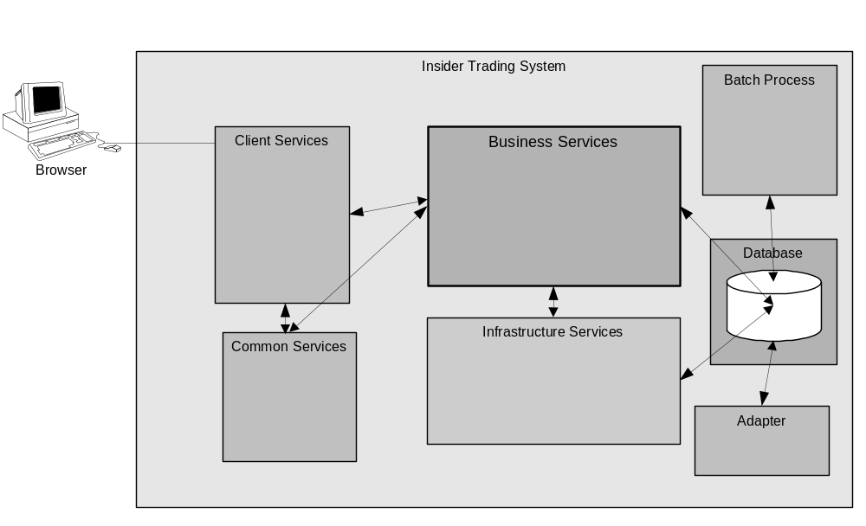The Insider trading system will be comprised of the following five logical packages of functionality
- Client Services (MVC Struts, Jetty)
- Common Services (Application Security Management Services)
- Business Services
- Infrastructure Services
- Batch Process
- Adapter

The Client Services will be based on the MVC Model containing view, model and controller components. These allow the interaction of the client interface with the system and vice versa. The presentation services also contain the Jetty service responsible for receiving http requests and forwarding it to the MVC classes.

The common services are services that are used by both the client and the business services. The main component is the Application Security Management service.

The Business Services constitute the core functionality of the system exposing various business object model entities. The Business Service will be built based on the foundation framework developed by CBOE Direct.

Infrastructure Services constitutes the various infrastructure services that CBOE Direct built to support security, logging and various other functionality.

There are some batch processes involved in the population of the tables used by the system.

The Security adapter will be responsible for propagating the user updates to the Security Admin Service. The adapter is discussed in detail in the security architecture.

Diagram below are the detailed logical components of the insider Trading system

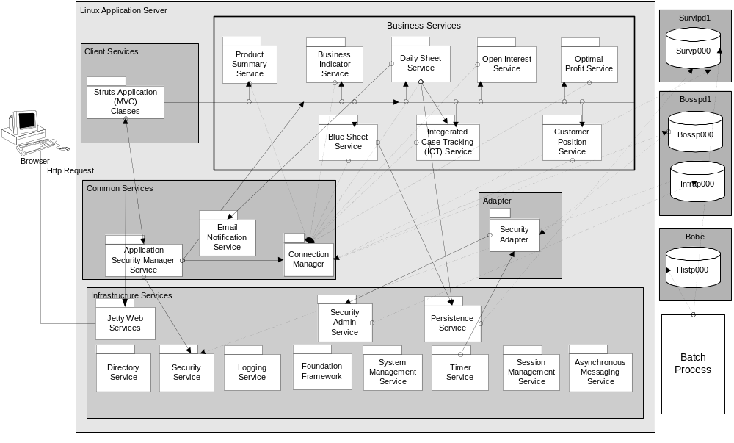

Logical Packages

Client Services

The Client Services contains the MVC Struts Classes

MVC Struts Classes

When the Struts ActionServlet receives a request from Jetty, it runs the request through a gauntlet that processes the locale, mapping, form bean and finally the action. Each use case in the system has an associated Controller Class, View Class and a model class. The model classes communicate with the business services to query and update information based on user requests.

View
(Form Classes)

Controller
(Action Classes)

Model
(Model classes)

Business Services

Jetty Service

Browser
Application

The following are the sets of MVC classes that are used to display the GUI

- Login
- Stock Pick List
- Stock Detail
- Open Interest
- LOPR
- Blue Sheet
- Case List
- Case Detail
- Optimal Profit
- Daily Sheet
- Aberration

Common Services

Application Security Management Service

Application Security Management Service (ASMS) is responsible for both client and business service security. ASMS has two major responsibilities

- Security Manager

- ASMS will validate the user ID and password with the security Service
- ASMS will provide client menu access based on the roles that a user ID belongs to

- Session Manager

- ASMS will maintain a memory mapping of HTTP Session ID, User ID, Security Session ID, roles and last access time
- ASMS will provide the security session ID if the HTTP Session ID is supplied
- ASMS will time out sessions that have been idle for a business defined period

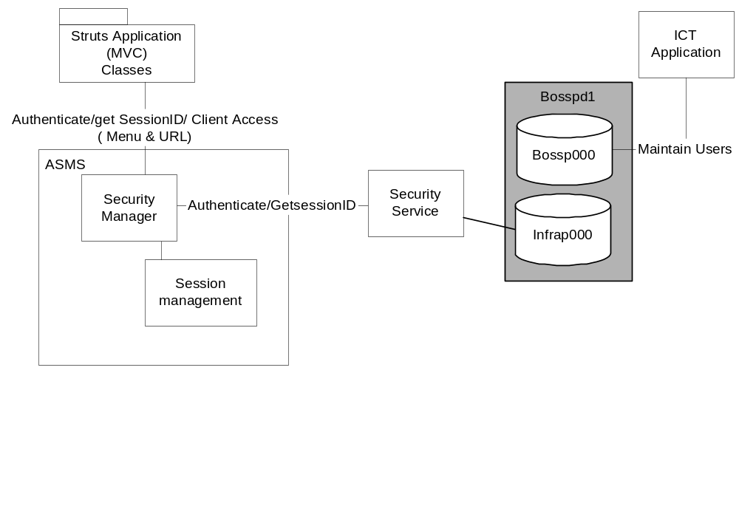

Email Notification Service
Email notification Service is a common general-purpose service responsible for sending emails. This service will be invoked by the business Service(s) in the event that the users need notifications about actions performed.

Connection Pool Manager

The connection Pool Manager will host a pool of connections to both survp000 and bossp000 databases. The connection pool manager will provide connections to all the services upon request and add it back to the pool once the connection is utilized.

Business Services

Business Indicator Service

The Business indicator service is responsible for providing Summary information of the business activity on a post trade date basis.

Access Path: Oracle procedures and packages using JDBC

Product Summary Service

Product Summary Service is responsible for providing end of day product Summary information. The service provides

- The initial list of stocks based on business conditions to be reviewed by the manager for potential Insider Trading activity.
- The details of the stock
- The details of aberration on the stock.

Access Path: Oracle procedures and packages using JDBC

Daily Sheet Service

Daily Sheet Service is a primarily Insider trading specific service responsible for maintaining daily sheet information entered by managers. This service will be developed using J-Grinder to manipulate data. The Service will provide

- Modifications to Daily sheet information for Managers
- The details of Daily sheet based on a particular date for Managers
- The cases details for an analyst

Access Path: J-Grinder

Open Interest Service

Open interest service is responsible for providing Open interest information for customers and firms. The service provides option open interest on the long side (long call and short put) and short side (short call and long put) by clearing firm for the input trade date range

Access Path: Oracle procedures and packages using JDBC

Optimal Profit Service

Optimal Profit service is responsible for providing optimal profit information based on trades done during a trading period given a trade date on which the trade was executed.

Access Path: Oracle procedures and packages using JDBC

Blue Sheet Service

Blue Sheet services is responsible for tracking blue sheet information and providing blue sheet information. The service provides

- Maintenance for tracking blue sheet information
- Providing Blue sheet information
- Providing blue sheet tracking information

Access Path: Oracle procedures and packages using JDBC for blue sheet display and J-Grinder for Blue Sheet Tracking

Integrated Case Tracking Service

Integrated case tracking (ICT) Service is responsible for creating new cases in the ICT system. This service also provides case status inquiry and analyst assign capabilities. This service is the only service that will handle transaction management and updates to the database using existing oracle packages. The service will request the connection Pool manager for a connection to “Bossp00” and will use the connection to execute the packages.

Access Path: Oracle procedures and packages using JDBC

Customer Position Service

The customer Position service is responsible for providing LOPR information for customers.

Access Path: Oracle procedures and packages using JDBC

Infrastructure Services

The infrastructure services provided by CBOE Direct will be re-used. The following are some of the services that Insider Trading System uses

- Security Service
- Logging Service
- Systems Management Service
- Persistence Service

Jetty Services

Jetty Web Server will be bundled into a service by the infra structure group. This service will be instantiated as part of our business service. The Jetty is a Java HTTP Server and Servlet Container. When the browser posts a request, Jetty uses Jasper service to translate the jsp file into java code. Jetty also acts as a container hosting the Struts ActionServlet. When the path of the request matches the servlet context in the ActionServlet, the jetty container forwards the request to the ActionServlet.

Batch Processes

3.1.5.1 Aberration Processing

- A daily Data Warehouse load process loads a table from ILX data with option class summary open interest and cleared volume for a trade date.
- On a daily basis, the batch process aggregates to the underlying symbol and previous 60 trade days the options open interest and cleared volume (CLASS_ARCH and TBA table).
- The following is performed on a 60-day moving average basis first, then on a 30-day basis:
  - The open interest and cleared volume moving averages, standard deviations and third standard deviations are calculated for each underlying symbol. There must be option open interest and/or volume for the full moving average time period.
  - For the current trade date, each underlying symbol’s aggregated open interest and cleared volume is compared to the respective third standard deviation.
    - If the open interest is at or above the open interest third standard deviation and the cleared volume is at or above the cleared volume third standard deviation this signifies an aberration in open interest and volume, then the underlying symbol’s data is inserted into the aberration table (UNDLY_SEC_ABERR) with a VLO type code
    - If only the open interest is at or above the open interest third standard deviation this signifies an aberration in open interest, then the underlying symbol’s data is inserted into the aberration table (UNDLY_SEC_ABERR) with an OPIN type code.
    - If only the volume is at or above the volume third standard deviation this signifies an aberration in cleared volume, then the underlying symbol’s data is inserted into the aberration table (UNDLY_SEC_ABERR) with a VOL type code.
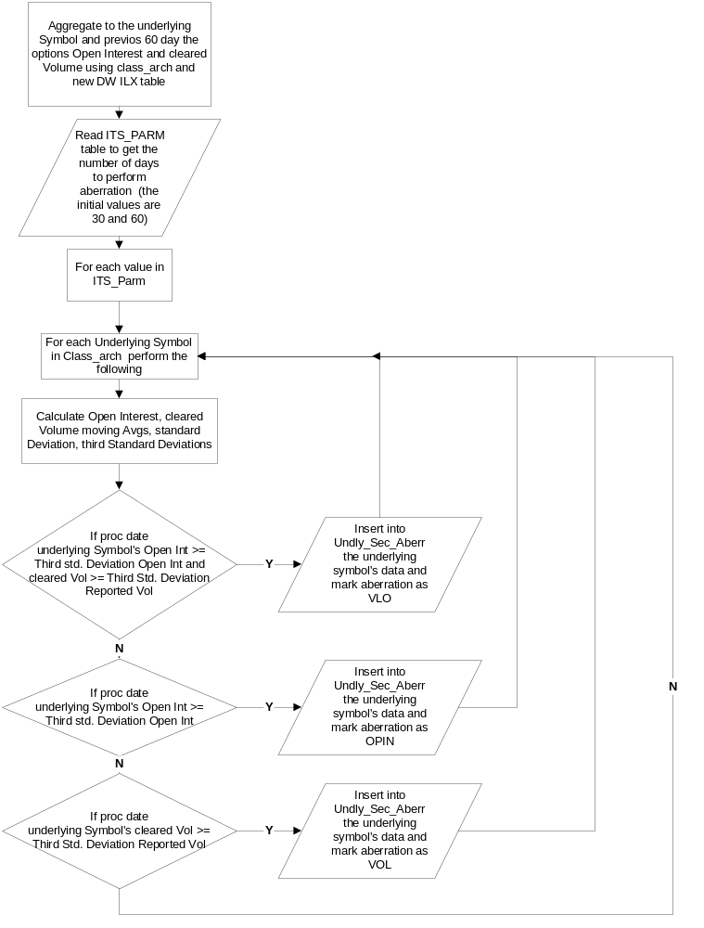

3.1.5.2 Blue Sheet Tracking

- The batch process will read all the blue sheet data(Blue_sheet_T) loaded in Survp000 for the current processing date(file_creat_date = current date)
- For each blue sheet entry in the blue_sheet_t table the following will be done
  - Create a new entry in ITS_BS_Track_RCD with the firm #, ICT # and the receipt date
  - Check daily sheet (ITS_DAILY_SHEET_T) for the ICT # and get the analyst Name
  - Retrieve the analyst email address from Staff_Persn table using the analyst name
  - Send an Email to the analyst email address indicating that their requested blue sheet information is available.
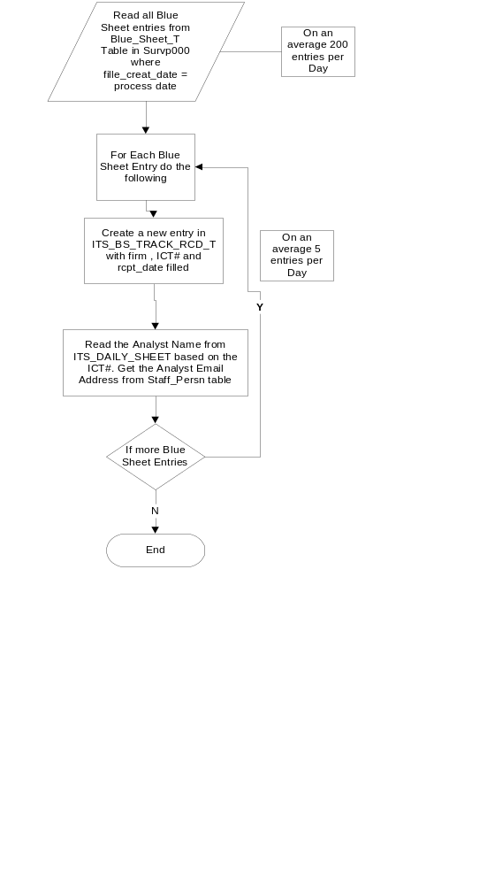

Adapter

Security Adapter

Security Adapter will read updates to user table and automatically communicate the changes to Security admin (which will internally update the security tables). Refer to the Security Architecture for more details

Processing Paradigm

This section describes the common processing paradigm using software design patterns.

Foundation Framework

The Foundation Framework is an application server framework, consisting of a set of Java classes developed by CBOE Direct, which enables using infrastructure services in a consistent and effective manner for both the Application Service developers and Business Service developers. All the business services will be developed using the Foundation framework. JGrinder will be primarily used for all transaction management (except Integrated Case Tracking Service).

Batch

Insider trading system is for the most part an offline reporting system. Most of the reports produced by the system are based on data generated by batch processing done at the end of trade date. The batch process are Unix shell scripts that run at the end of the day processing existing oracle data using SQL scripts, oracle stored procedures and packages.

JDBC

The business services used by the Insider Trading system for the most part provides reports combining multiple tables. The access to the data from the service is done using JDBC calls. All of the services with the exception of Daily sheet and Blue Sheet service use JDBC to connect to Oracle and retrieve the data.

Internet

The client for the insider trading system will be browser-based application using jetty web server and struts MVC model.

Oracle Packages

All access to the database with the exception of updates and transaction management will be done using oracle packages.

User Interfaces

To be added later

Process View

Insider Trading Server

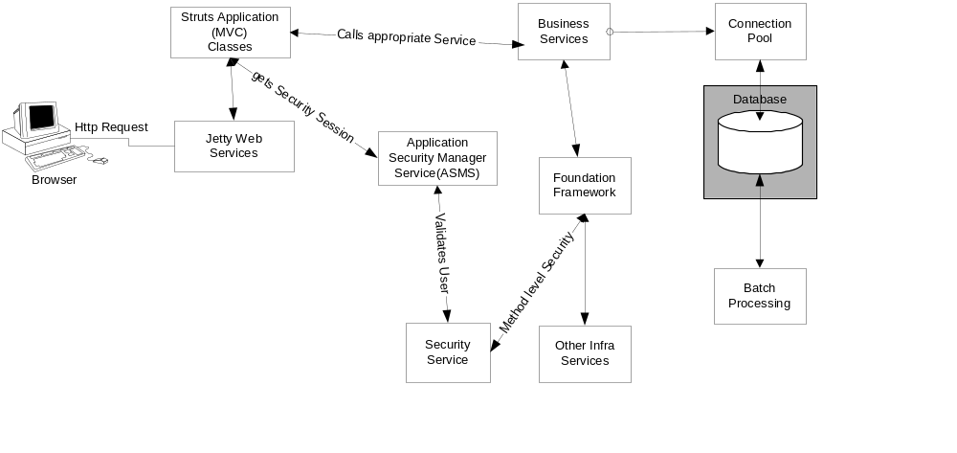

- When the user submits a http request to the application server, the application server sends the request to jetty service.
- The Jetty web service forwards the call to Struts ActionServlet
- The struts ActionServlet will forward the call to the appropriate controller class in the struts MVC framework which would then forward it to Model
- The model class in the struts MVC would then call the ASMS to validate the user session
- ASMS on successful validation with infrastructure security service will maintain a memory map of the jetty HTTP session ID, User ID and security service session ID and return back a success message.
- The model class will then call the corresponding Business service
- The Business Service will invoke the security service through the foundation framework façade to verify method level access
- If the user has the appropriate rights then the business service will communicate with the database and return to the struts MVC classes the results
- The struts MVC classes will then render the results appropriately in the browser

Deployment View

Process Deployment
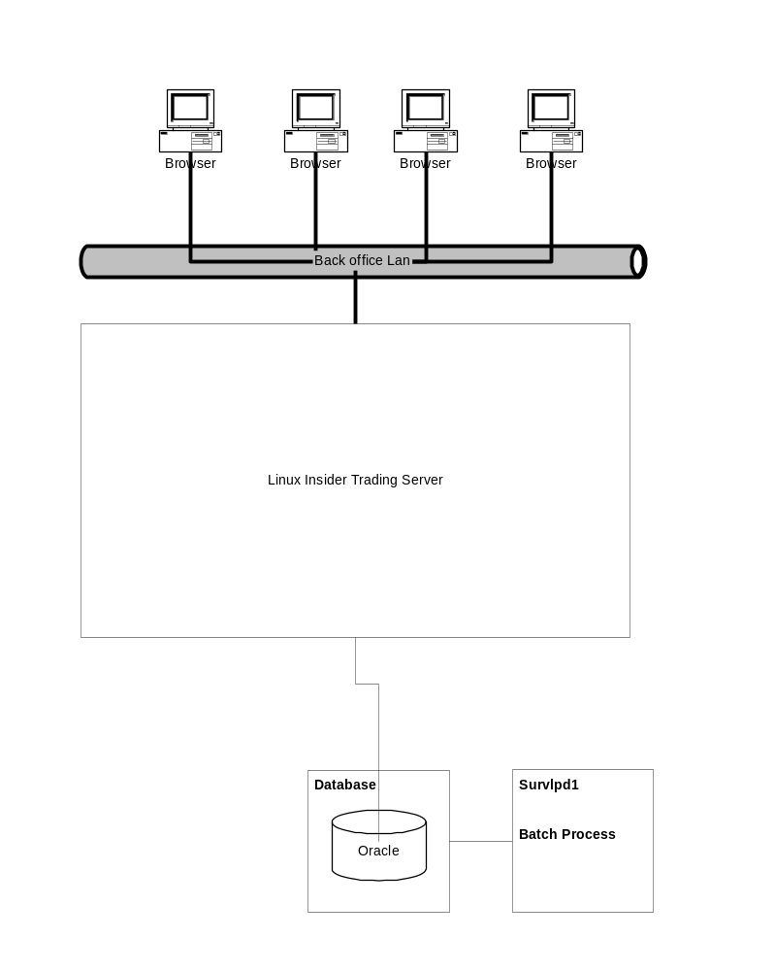

Processing Needs (Application Layer)

Hardware

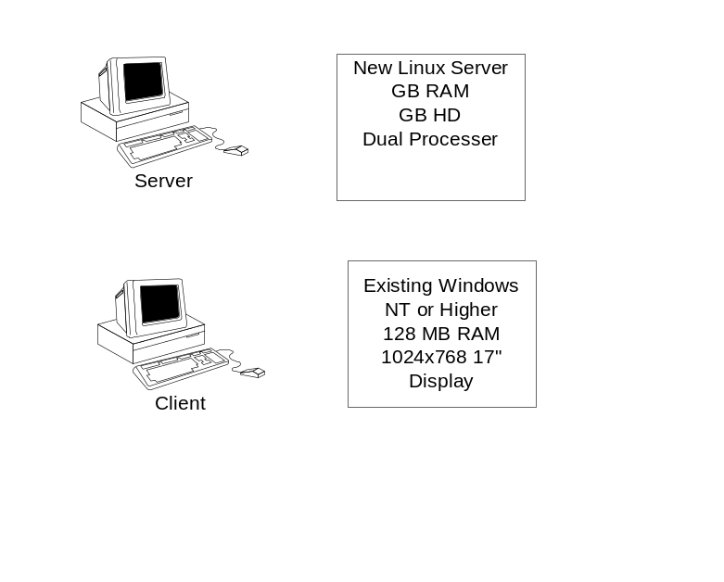

Performance

Insider trading system will primarily use Oracle packages and stored procedures to perform retrieval of data. Oracle provides stored procedure caching to improve performance on calls to the database.

Insider trading system will be implemented as a three-tier application. The user interface will be a thin client browser with the web service and business service loaded in a Linux server. The number of users using Insider Trading system is limited at this point. The Linux server hosting the web service and business service will be capable of handling the load. Insider trading system is built using the Foundation framework. This provides the additional flexibility to deploy the system as N-tier if performance becomes vital.

Availability/Reliability

The Insider trading system will be deployed on two Linux servers with fail over capabilities. The cold backup Linux machine will be used in the event that the primary Linux server goes down.

The Linux Server will have disk fail over and mirrored disks. If one of the disks fails, the other disk will be used as fallback.

In the event availability becomes an issue in the future, Foundation framework provides the flexibility to have master slave configurations.

Migration

All the interfaces between components will be versioned to ensure the migration between the iteration and phases of development. Insider Trading services will be deployable with multiple versions. As far as deployment is concerned, each service and version comprises a unique deployable service.

Data Needs (Information Layer)

Physical Location

The data required for the Insider trading system will be stored in two databases.

- Survp000 (survlpd1)
- Bossp000(bosspv1)

Capacity

Most of the tables required by the system are already in production environment with online retention period required by business. There will be new additional tables created and will have a retention period required by business.

Integrity

Backups of the tables used by the system are already taken care of by existent periodic backups of the oracle server. The integrity requirements of the system are addressed in the E-R diagram.

Access

Each user of the system is defined a role that they are associated with. The security of the insider trading system is handled in 4 ways.

- Menu Level Security
Menu Level Security is a client level security providing the users only those menu items that they have access to.
- Service Level Security
When a service is deployed, the rights of each method invocation are assigned to roles in the security service database. This would enable service level access only to users who have the appropriate rights.
- User Authentication
Each user is authenticated with the security service before they can invoke any of the service.
- Package level security
All the oracle tables are accessed through stored procedures. No Table rights are provided to the users. The rights to execute stored procedures are provided to oracle user IDs that are not known to the users. Only the services that access the stored procedures are aware of the oracle user ID through connection pools.

Management

Oracle 9i (Solaris 2.8) will be used for data management. The file system and Oracle 9iwill be used for Log Service messages, depending on quality of service.

Migration

Daily sheet information currently stored in access tables will be migrated to oracle tables. All the daily sheet data will be loaded into the new oracle table as part of the project.

Hardware Installation

A new Linux server will be deployed in production for the Insider Trading System. The Linux server will be added to the current PATROL to enable monitoring.

Third-Party Products

This section identifies the third-party products required by Insider Trading System

- Java SDK, SDK for Enterprise
- Oracle 9i
- Oracle JDBC 8.0406 Thin Driver
- Struts Tag Libraries
  - Jakarta Struts
  - Struts – Layout
  - Struts - Menu
- Jetty
- Linux
- Clear case
- Ecclipse or some other IDE
- SQL Station

Software Installations

[Describe the expected method of deploying the application into the operational environment. Define the media and format for deploying the system. For example, the application could be a Java JAR on a server that each client downloads and installs. Describe the state of the system before and after the software installation. Define any dependencies on hardware, third party software, or other applications.]

Maintenance

[Describe the approach for routine maintenance, such as software patches. Describe emergency maintenance procedures, such as backing out an installed version of the application to the previous version, due to some catastrophic errors in the software.]

Database Model

